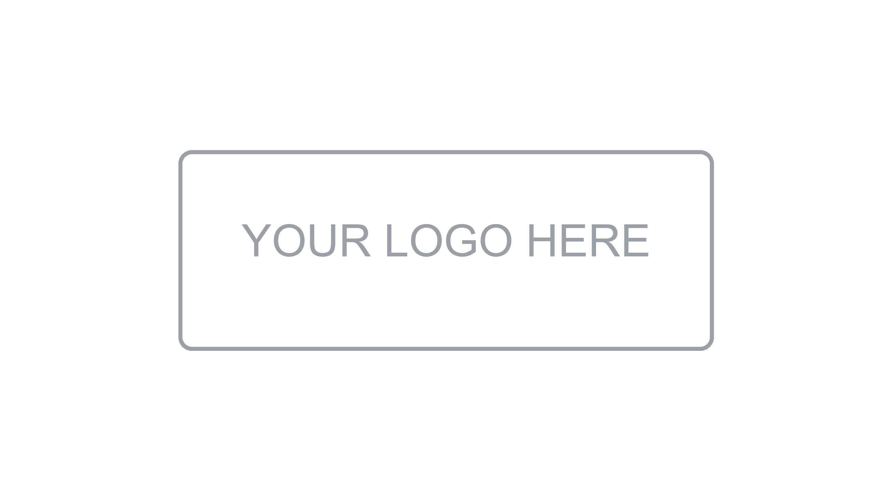

Requirements
Documentation

[Project Name]
Version [X.X] | [Month Year]
Prepared by: [Author Name] | [Team / Area]

About this document
Requirements Documentation

What is this document?
This document defines what the system must do — both from a functional and non-functional perspective. It captures the requirements gathered from stakeholders, expressed as functional requirements, non-functional requirements, use cases, and user stories. It serves as the contractual baseline between the business and the development team, and as the primary input for design, development, and testing activities.
Who should read it?
This document is intended for business analysts, product owners, developers, QA engineers, architects, and project managers involved in defining, building, or validating the system.
What does it contain?
Document Information & Change History | Version control, authorship, and revision log of this document.
Introduction | Purpose, scope, intended audience, and key definitions.
Stakeholders | List of stakeholders and their roles in the requirements process.
Functional Requirements | Detailed description of what the system must do, organized by module or feature.
Non-Functional Requirements | Performance, security, scalability, usability, and other quality attributes.
Use Cases | Actor-system interaction scenarios described in structured format.
User Stories | Agile-style requirements written from the user perspective with acceptance criteria.
Requirements Traceability Matrix | Mapping between requirements, use cases/stories, and test cases.
References & Approvals | Related documents and formal sign-off section.

1. Document Information

Project | [Project Name]
Document Type | Requirements Documentation
Version | [X.X]
Author(s) | [Name(s)]
Reviewer(s) | [Name(s)]
Date | [DD/MM/YYYY]
Status | [Draft / In Review / Approved]

2. Change History

Version | Date | Author | Description of Change
1.0 | [DD/MM/YYYY] | [Name] | Initial version

3. Introduction

3.1 Purpose
[Describe the purpose of this document. Example: This document specifies the functional and non-functional requirements for the [Project Name] system, serving as the baseline for design, development, and testing.]

3.2 Scope
[Define the boundaries of the system covered by these requirements. What is included and what is explicitly excluded.]

3.3 Audience
[List the intended readers: product owners, business analysts, developers, QA engineers, architects, project managers.]

3.4 Definitions and Acronyms
Term / Acronym | Definition
FR | Functional Requirement
NFR | Non-Functional Requirement
UC | Use Case
US | User Story
[Term] | [Definition]

4. Stakeholders

Stakeholder | Role | Responsibility | Contact
[Name] | [Product Owner] | [Validates requirements] | [email]
[Name] | [Business Analyst] | [Elicits and documents requirements] | [email]
[Name] | [Tech Lead] | [Reviews technical feasibility] | [email]
[Name] | [QA Lead] | [Validates testability] | [email]

5. Functional Requirements
[Functional requirements describe the specific behaviors, functions, and features the system must provide. Organize them by module or functional area.]

5.1 Requirement Format
Field | Description
ID | Unique identifier (e.g. FR-001)
Title | Short descriptive name
Description | Detailed explanation of the requirement
Priority | High / Medium / Low
Source | Stakeholder or document origin
Status | Proposed / Approved / Implemented / Verified

5.2 Module: [Module Name]
ID | Title | Description | Priority | Status
FR-001 | [Short title] | [The system shall... detailed description of the behavior expected.] | High | Proposed
FR-002 | [Short title] | [The system shall... detailed description of the behavior expected.] | High | Proposed
FR-003 | [Short title] | [The system shall... detailed description of the behavior expected.] | Medium | Proposed
FR-004 | [Short title] | [The system shall... detailed description of the behavior expected.] | Low | Proposed

5.3 Module: [Module Name]
ID | Title | Description | Priority | Status
FR-005 | [Short title] | [The system shall... detailed description of the behavior expected.] | High | Proposed
FR-006 | [Short title] | [The system shall... detailed description of the behavior expected.] | Medium | Proposed

6. Non-Functional Requirements
[Non-functional requirements define quality attributes and constraints the system must meet. They apply across all functional areas.]

6.1 Performance
ID | Description | Metric / Target | Priority
NFR-001 | [The system shall respond to user requests within...] | [e.g. < 2 seconds under normal load] | High
NFR-002 | [The system shall support concurrent users...] | [e.g. up to 500 simultaneous users] | High

6.2 Security
ID | Description | Metric / Target | Priority
NFR-003 | [All data in transit shall be encrypted using...] | [e.g. TLS 1.2 or higher] | High
NFR-004 | [The system shall enforce role-based access control...] | [e.g. RBAC with least privilege] | High

6.3 Availability & Reliability
ID | Description | Metric / Target | Priority
NFR-005 | [The system shall maintain uptime of...] | [e.g. 99.9% monthly] | High
NFR-006 | [The system shall recover from failure within...] | [e.g. RTO < 1 hour] | Medium

6.4 Usability
ID | Description | Metric / Target | Priority
NFR-007 | [The system shall be accessible following...] | [e.g. WCAG 2.1 AA standards] | Medium
NFR-008 | [New users shall be able to complete core tasks without training in...] | [e.g. < 30 minutes] | Low

6.5 Scalability & Maintainability
ID | Description | Metric / Target | Priority
NFR-009 | [The system shall scale horizontally to handle...] | [e.g. 10x current load] | Medium
NFR-010 | [The codebase shall maintain test coverage of at least...] | [e.g. 80%] | Medium

7. Use Cases
[Use cases describe interactions between actors (users or external systems) and the system to achieve a goal. Each use case follows a standard format.]

7.1 Use Case Format
Field | Description
ID | Unique identifier (e.g. UC-001)
Name | Descriptive name of the use case
Actor(s) | Who initiates or participates
Preconditions | State of the system before execution
Main Flow | Step-by-step normal sequence of events
Alternative Flow | Variations or optional paths
Exception Flow | Error or failure scenarios
Postconditions | State of the system after successful execution

7.2 UC-001: [Use Case Name]
Field | Detail
ID | UC-001
Name | [Use Case Name]
Actor(s) | [e.g. Registered User, Admin]
Preconditions | [e.g. User is authenticated and has the required permissions]
Main Flow | 1. [Step one]  2. [Step two]  3. [Step three]  4. [System responds with...]
Alternative Flow | [e.g. If the user provides invalid data, the system displays a validation message]
Exception Flow | [e.g. If the external service is unavailable, the system shows an error and logs the event]
Postconditions | [e.g. The record is saved and the user is redirected to the confirmation page]

7.3 UC-002: [Use Case Name]
Field | Detail
ID | UC-002
Name | [Use Case Name]
Actor(s) | [Actor(s)]
Preconditions | [Preconditions]
Main Flow | [Main flow steps]
Alternative Flow | [Alternative flow]
Exception Flow | [Exception flow]
Postconditions | [Postconditions]

8. User Stories
[User stories capture requirements from the end-user perspective in a simple, conversational format. Each story includes acceptance criteria that define when it is considered done.]

8.1 User Story Format
Field | Description
ID | Unique identifier (e.g. US-001)
Title | Short descriptive name
Story | As a [role], I want to [action], so that [benefit]
Acceptance Criteria | Given [context], When [action], Then [expected result]
Priority | High / Medium / Low
Story Points | Effort estimate
Status | Backlog / In Progress / Done

8.2 Feature: [Feature Name]
ID | Story | Acceptance Criteria | Priority | Points
US-001 | As a [role], I want to [action], so that [benefit]. | Given [context], When [action], Then [result]. | High | [#]
US-002 | As a [role], I want to [action], so that [benefit]. | Given [context], When [action], Then [result]. | High | [#]
US-003 | As a [role], I want to [action], so that [benefit]. | Given [context], When [action], Then [result]. | Medium | [#]
US-004 | As a [role], I want to [action], so that [benefit]. | Given [context], When [action], Then [result]. | Low | [#]

9. Requirements Traceability Matrix
[The traceability matrix maps each requirement to its corresponding use case or user story and test case, ensuring full coverage and no gaps.]

Req. ID | Requirement Title | UC / US | Test Case ID | Status
FR-001 | [Title] | UC-001 | TC-001 | Pending
FR-002 | [Title] | US-001 | TC-002 | Pending
FR-003 | [Title] | UC-002 | TC-003 | Pending
NFR-001 | [Title] | N/A | TC-010 | Pending
NFR-003 | [Title] | N/A | TC-011 | Pending

10. References and Related Documents
Document | Description | Location / Link
Architecture Documentation | System architecture overview | [Link / Path]
Design Documentation | Detailed design specs | [Link / Path]
Evidence Documentation | Test plan and test cases | [Link / Path]
[Other Document] | [Description] | [Link / Path]

11. Approval

Role | Name | Signature | Date
Author | [Name] |  | [DD/MM/YYYY]
Product Owner | [Name] |  | [DD/MM/YYYY]
Technical Lead | [Name] |  | [DD/MM/YYYY]
Project Manager | [Name] |  | [DD/MM/YYYY]

